Educational Technology in Science Education:
Teaching Climate Change through Citizen Science

During our next two class sessions, we will focus on educational technology in science education. We will model the use of citizen science as way to integrate technology into elementary science instruction in ways that support science teaching and learning goals, particularly in relation to teaching climate change. In preparation, please complete the activities below.

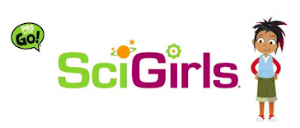 | Activity 1  Building on our examination of informal science education resources, please view the full episode of the PBS Kids show, SciGirls, entitled Feathered Friends (26:41). Episode link: http://pbskids.org/video/?guid=ac3b0e0e-2361-44c2-8a08-9b77bb599977
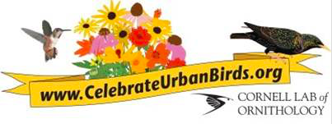 | Activity 2  In the episode, the girls engaged with Cornell Lab of Ornithology’s citizen science initiative, Celebrate Urban Birds. Please explore the Celebrate Urban Birds website at: http://celebrateurbanbirds.org  In preparation for our in-class activity, preview the data sheet in the Celebrate Urban Birds kit: http://celebrateurbanbirds.org/getting-started/get-your-kit/

Come to class prepared to discuss the questions below. You are not required to write down your responses in advance.

- In the SciGirls episode, the girls collected and reported observational data about local bird populations that would be used by professional research scientists.
- What do you think your students could gain from this kind of science learning experience?
- What makes this approach to science engagement unique?

- Based on what you understand about the Celebrate Urban Birds project:
- What would your students need to know how to do in order to collect and report accurate data?
- What advance preparation would you, as a teacher of science, need to do to get students ready?

