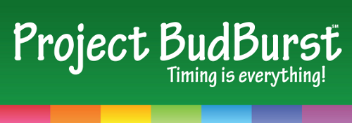

Through Project Budburst, citizen scientists collect data about how plants in their communities change with the seasons. These data can help the public and scientists to understand how plants are responding to a changing climate.

A Guided Tour:

Step 1. Begin by taking a look at the Project BudBurst homepage to get a sense of the project. | http://budburst.org/home

Step 2. Read about the two ways participants can collect data: looking at the same plant over time (regular reports) or one-time observations (single reports). Think about why, as a teacher, you might choose one approach over the other. | http://budburst.org/two-ways-to-observe

Step 3. Review the list of plants that you can choose to observe in MD. Do you know if any of them can be found near your school? | http://budburst.org/plantresources_list_bystate?Distribution=MD#list
What tools could you use to help identify plants? | One suggestion: http://leafsnap.com/

Step 4. Now take a look at one example of a data reporting form. Would your students be able to work with this? What supports might they need? | Regular Report Form: http://budburst.org/documents/871408/879709/Deciduous_regular_report.pdf/14d3cd4d-2218-481f-8d73-db96ef1c206b  Single Report Form:  http://budburst.org/documents/871408/879711/Deciduous_single_report.pdf/bd678f02-0219-45d5-8163-0b72e5c7977a

Step 5. Look at the map of data reported so far in 2015 related to leaf color changes. What questions could students investigate using this data? | http://budburst.org/results_byphenophase?year=2015&Phenophase_ID=color
What could they investigate by looking at the data from earlier years (e.g., comparing it to 2010 data)? | http://budburst.org/results_byphenophase?year=2010&Phenophase_ID=color

If you have time, browse the resources available for K-4 educators. http://budburst.org/education_k-4

