Engaging Learners in Citizen Science Data Exploration:
A Focus on Climate-Related Citizen Science Initiatives

Overview. This session will engage teacher candidates in considering the potential of including citizen science elements in their own science teaching. They will reflect on how citizen science can provide opportunities for educational technology integration in the science classroom, and discuss related benefits and challenges. In grade-level teams, teacher candidates will examine at least one additional citizen science project that aligns with a disciplinary core idea they will be expected to teach in science. In reflecting on these activities, teacher candidates will complete a drawing activity in which they envision approaches to using citizen science as a pedagogy in their teaching practice.

Objectives. Teacher candidates will:
- Examine and interpret citizen science data collected by themselves and others
- Articulate how they could incorporate citizen science into their science teaching practice to address grade-specific science content

Preparation (Teacher candidates). Teacher candidates will have collected and reported Celebrate Urban Birds data in the previous session.

Preparation (Instructors). On the classroom computer, log in to the Celebrate Urban Birds data dashboard: https://secure.birds.cornell.edu/cassso/login?service=http%3A%2F%2Fcelebrateurbanbirds.org%2Fcub%2Fj_spring_cas_security_check

Materials
- Prepared PPT presentation (PDF or PowerPoint Presentation)
- Computer with access to Celebrate Urban Birds website
- Guided tours of citizen science projects
  - CoCoRaHs Guided Tour
  - Journey North Guided Tour
  - Project Budburst Guided Tour
- Copies of drawing protocol (1 per intern) (PDF or Word Document)
- Colored pencils

Procedures
Time: 15 min  Materials:  - PPT slide 2 | Small group debrief of data collection and reporting experience. Teacher candidates sit in groups with their teams from the last class session.  Teacher candidates discuss the questions:  - What did you learn from the data collection and reporting experience? (Consider this question from the perspective of a teacher and a learner)
Time: 5 min  Materials:  - PPT slide 2 | Quick whole group debrief. Whole-group sharing of key ideas discussed in the small groups.
Time: 15 min  Materials:  - PPT slide 3-5  - Celebrate Urban Birds website | Exploring citizen science data. Pose the question: What could science learners do with the data they and others have reported?  Show the clip from SciGirls (linked on the PPT slide) that shows what happens to the data when it’s entered on the Celebrate Urban Birds website.  On the Celebrate Urban Birds website, model how to explore all of the submitted data in the lower right corner of the data dashboard:  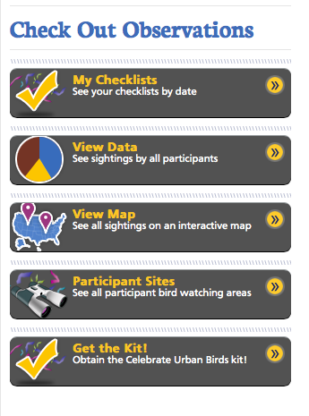  Teacher candidates can also use their laptops to log in and follow along.  Key question: What stories do you think the data are telling?  First, click on the “View Data” option to see Top Species.  - What stories are the data telling?  - How do these frequencies compare to what we observed?  - How could you engage students with this data?  Go back, and click on “Participant Sites” to see where data have been collected. Show an example of how you can look at one site and see which species were observed there.  - What stories are the data telling? (not necessarily where birds occur, but where people are participating in citizen science)  - How could you engage students with this data?  Briefly show more sophisticated examples of data representation on eBird. Under “Citizen Science Network” at the top of the page, select eBird from the dropdown menu.  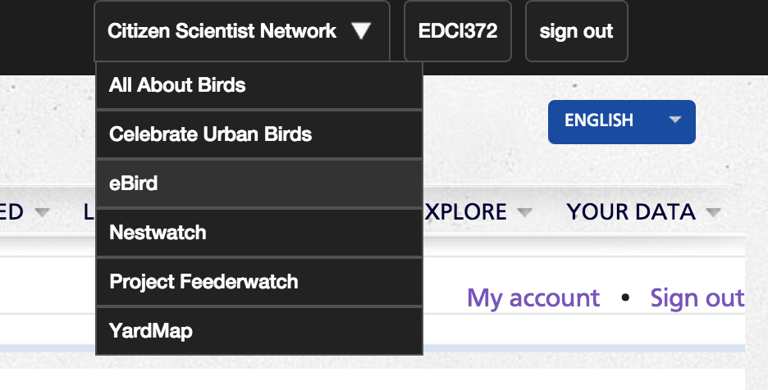  Select: Explore Data  Note the wide variety of ways citizen science data are represented here. Real time data  Select: Bar Charts  Select: Maryland* Prince George’s County*  Find Baltimore Oriole* on the list  - On green graph (data by month): What story does the graph tell about orioles in Prince George’s County? (not abundant year round, etc.)  - Look at line and bar graphs below. Click on Totals: What new inferences can you make from this representation?  *Or, select your location and a well-known bird species to examine
10 min | Data Exploration Debrief: Word Swarm. On the board, write “data” and draw a circle around it. Ask teacher candidates to recall some of the keywords they heard while talking about and examining the citizen science data (could be: representation, pattern, story, inference, etc.).
5 min  Materials:  - PPT slide 6 | Climate change connection. Tell teacher candidates to consider the example of climate change as a real-world issue we could learn about through citizen science data.  If we and others collect data over years and decades, the data may be able to tell us stories about what kinds of changes are happening in animal populations from past to present, and how these correlate with changes in climate conditions. [View the Audubon video on Slide 5 if teacher candidates have not yet seen it]  If we and others collect data over broad geographic areas, the data may be able to tell us stories about how species’ ranges may shift in the future given the changes already observed over space and time.  Look at map on Audubon website, modeling how Baltimore Oriole ranges are projected to change over the decades, given currently observed shifts in climate: http://climate.audubon.org/birds/balori/baltimore-oriole  Climate change is one example of a science topic you could teach by looking at bird data. Can you think of others? Are any of these topics you are responsible for teaching at your grade level?
Time: 5 min  Materials:  - PPT slide 7-8  - Links to Guided Tours of grade-level appropriate citizen science projects | Exploring the use of citizen science to teach grade-specific science content - Instructions. Have teacher candidates get into groups of 1-4 with others who teach their same grade level.  Explain that in grade level teams, teacher candidates will explore another citizen science activity that can help teach a key topic appropriate for their grade level.  In small groups, teacher candidates will take a “guided tour” of a citizen science website and consider how their students might engage with it as they learn about a science topic taught at their grade level.  Introduce the project options (Journey North, Project BudBurst, and CoCoRaHs) and show teacher candidates where to find the guided tour documents online.
Time: 10 min | Break
Time: 15 min | Exploring the use of citizen science to teach grade-specific science content – Work time. Teacher candidates have time to explore their selected citizen science project website, as guided by the Guided Tour documents online.
Time: 5 min | Whole group debrief. Each grade level team gives a brief overview of the citizen science project they explored, and shares a few ideas about how they could use it with elementary students (~2 min per grade level team).
Time: 15 min  Materials:  - Copies of drawing protocol (1 per intern)  - Colored pencils | Reflection drawing activity*. To reflect on the experience of engaging in citizen science and thinking about its potential uses in their own science teaching, teacher candidates individually complete drawings.  Distribute the drawing protocol (PDF or Word Document) to each intern, and colored pencils to each table.  The drawing prompt is: Draw yourself using citizen science in your science instruction with learners. Remind teacher candidates to write on the back of the sheet what they wanted to communicate in their drawing.  If time allows, provide an opportunity for teacher candidates to share what they drew (e.g., whole-group share out, reception line).

